Professional Staff Development Activities allows WATC employees, staff, and faculty to grow their knowledge base, stay current with best practices, and show that their expertise is meaningful in a rapidly transforming and ever-demanding marketplace. We ask that you record your experiences to demonstrate this knowledge.

1. Log into myWATC.
2. Select the Employee Tab.
3. Select Professional Development from the Intranet Links channel. 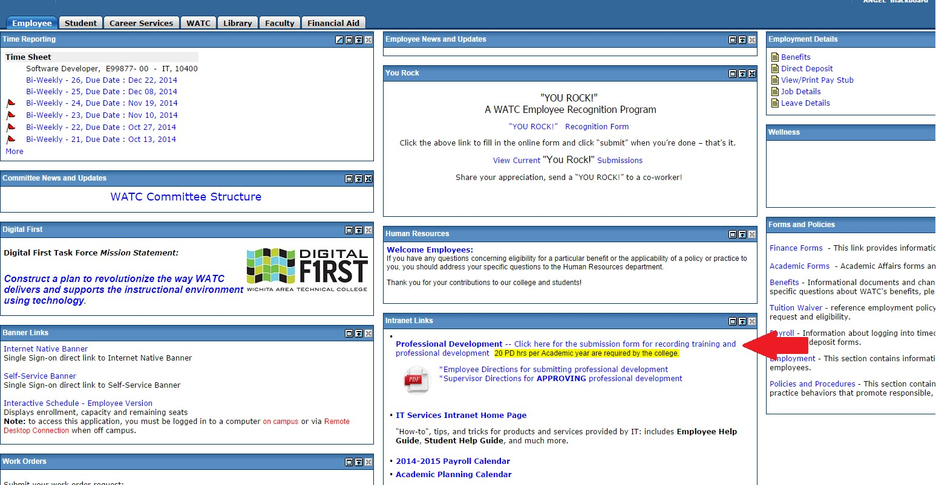

**How to add information about your own Professional Staff Development Activities**

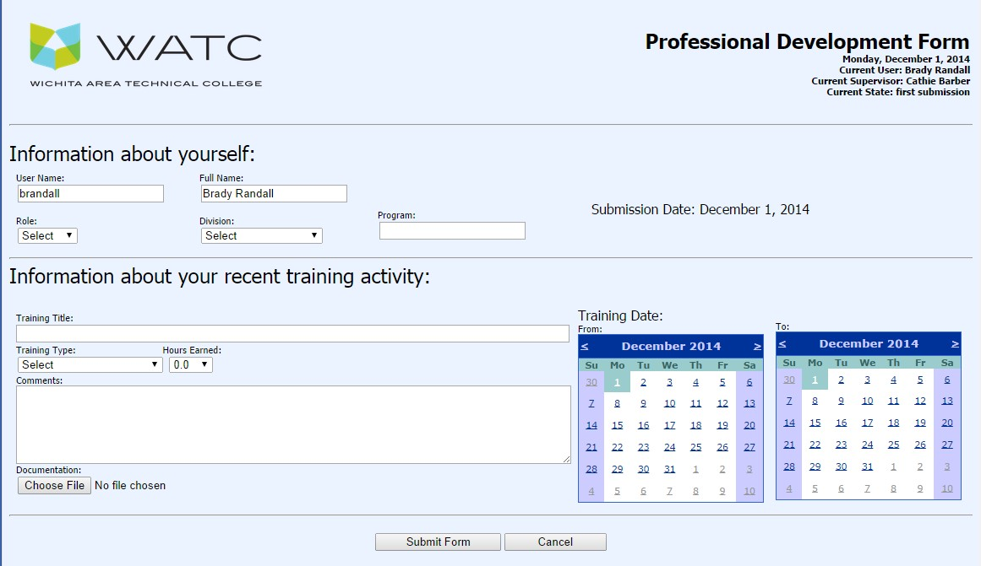

These entries are required:

1. In ‘Role’ and ‘Division’, a selection from the drop downs
2. In the ‘Training Title’ box, the title of the course or training session
3. In ‘Training Type’, a selection from the drop down
4. In ‘Hours Earned’, a selection to the nearest half-hour
5. In ‘Training Date’, click the calendars to select the beginning and ending dates

For ‘Comments’ you can use free text.

If documentation is required, click ‘Choose File’ to attach a file. There is a limit of 1 MB.

NOTE: If you click on a calendar after you choose a file it will drop the file.

Click ‘Submit Form’. The form below will display. (Clicking ‘Cancel’ during first submission drops all entries.)

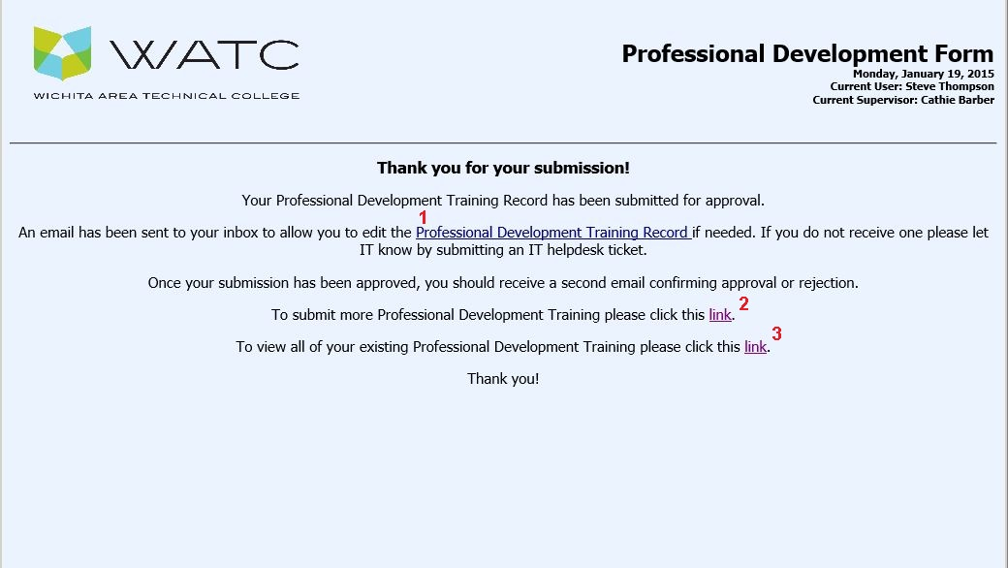

The links on this form allow you to; 1) modify the information just submitted, 2) submit another instance of training, or 3) view the report of all your submitted training information. To exit the form, simply close the tab or window in which it is displayed.

The submitted information has now been recorded and has initiated a workflow process to your supervisor for approval (or rejection pending further clarification).

You will receive notifications of the process via email similar to that seen below.

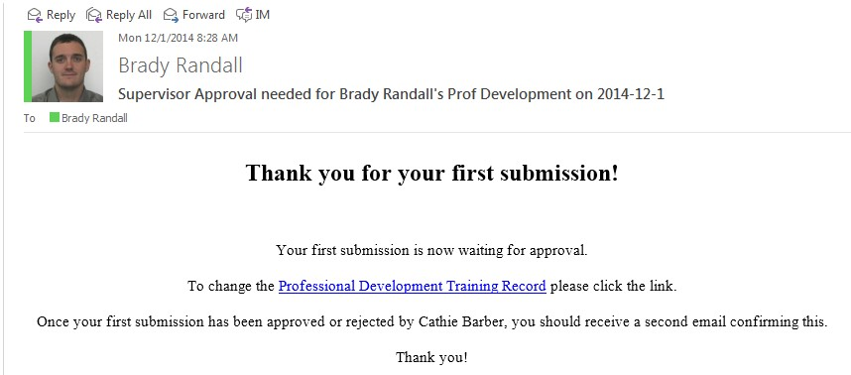

If you have any further questions about the Professional Development Application please either contact IT using a ticket to the IT help desk, or contact HR.